WEDE2050 POE

Skhuselo Lwanele Vilani

ST10435933

WEDE2050 POE

PurePack Solutions

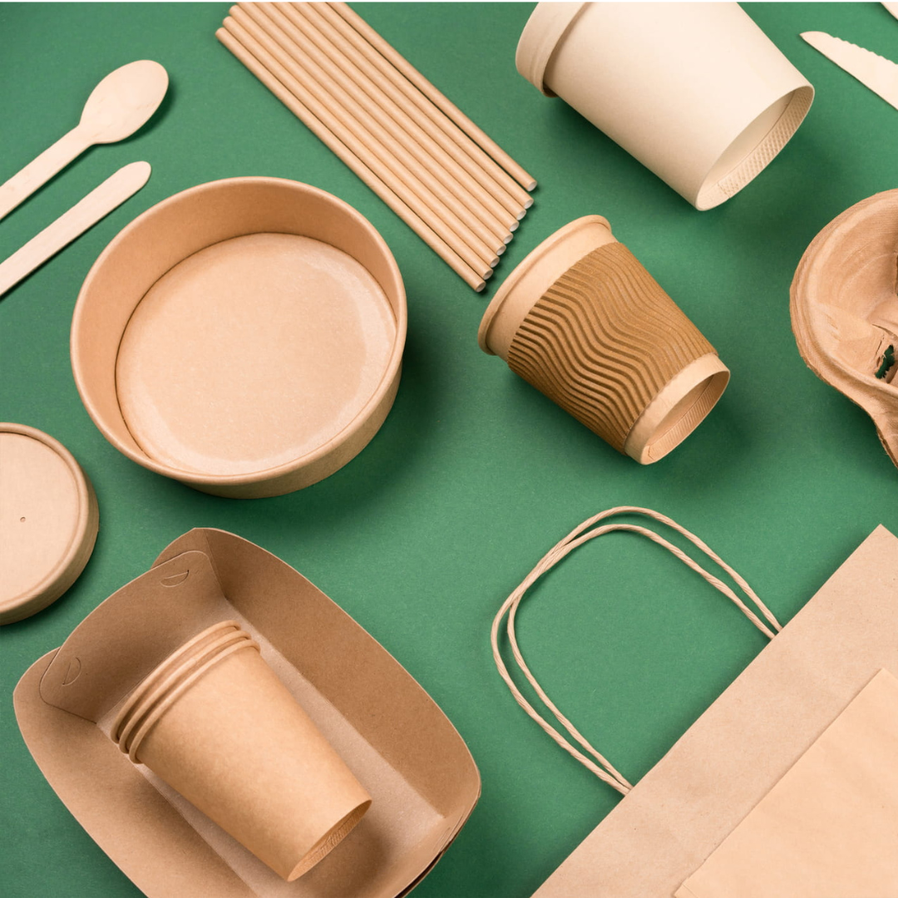

Table of contents

|  |  |
| --- | --- |
| Content | Page number |
| Target organization | 2 |
| Research and planning | 2 |
| Website proposal | 2-7 |
|  |  |
|  |  |

1. **Target Organisation**

**Chosen Business: PurePack Solutions**

Website Navigation – According to Moody R, 2024. Website navigation refers to how things like your menu, links, and sub-menus are structured and sorted on your website.

My website will have a menu on the top right of the screen on all web pages and links to other web pages on the home page to allow for easy navigation.

It will also have a web page dedicated to providing information about the business, including its values, vision, and mission statement. There will also be a web page for contact details should customers ever need to get in touch with an agent for more information on our products.

The website will also have a nice welcome message on the homepage just so users can feel comfortable whilst browsing. The colour scheme of the website will be one that is appealing to the eye, meaning it will have calming colours that don’t strain the user's eyes whilst browsing in all lighting conditions.

2.

**WEBSITE PROPOSAL**

**Orgainisation Overview:**

The name of the chosen business is PurePack Solutions. The business was founded in 2015 by John Smith and Bheki Mnisi, who both lived in heavily populated areas that were heavily polluted with plastic materials. They saw a business opportunity in the predicament that would see their community get rid of a pollution problem whilst also turning a profit.

They started Purepack Solutions, which would reduce plastic waste by creating packaging materials from recycled paper plant plant-based plastics. These biodegradable packaging materials would see a decrease in pollution, and they are eco-friendly.

The company’s target market is small to medium-sized businesses looking to reduce their carbon footprint and start-ups in the eco-friendly space.

The company’s mission is to reduce plastic pollution in communities by providing an eco-friendly and biodegradable packaging solution. The company’s vision is to see a nation free of pollution and plastic packaging that directly contributes to uncontrollable pollution in communities.

**Website Goals and Objectives**

My website's goals are to generate customer engagement by creating interactive content and engaging in community activities by hosting live events and running email newsletters, Another goal is to see sales and revenue growth; we will achieve this by spotlighting our best sellers and using ads to increase website traffic. The final goal of this website is to increase the visibility of our company, We will do this by telling our story and engaging with customers and potential customers through social media posts.

We will use customer satisfaction metrics like Net Promoter Score to measure customer satisfaction based on user feedback. We will also use a click-through rate to see the percentage of users who click on a link or an ad. We are also going to use traffic metrics to measure the number of visitors to the website.

**Proposed website features and functionality:**

**Homepage** – The homepage will have a logo for brand recognition and to know you’re on the correct website. It will also include our tagline and will have a navigation menu and some high-quality images, a search bar, content selections, and finally, some engagement features like short videos describing our products.

**Product Page** – The product page will contain pictures and prices of offered products as well as some information on the products it will also have a search bar to make it easier to search for the specific type of product the user might be interested in.

**About page** – The about page will contain information on the company, along with our vision and mission statement.

**Contact Us Page** – The contact us page will contain the various ways customers can contact the company whether it be through email, cell number or social platforms.

**Services page** – This page will display all the services we have to offer including our community engagement functions.

**Design and user experience:**

* The website will have a combination of the colors “Forest Green” (#OB6623) and “Emerald Green” (#50C878).
* The website will use the sans-serif font
* The website's layout will be a two column layout with the ability to switch to a featured photo or video layout for when the users are viewing images or watching the short videos.

**Technical Requirements:**

The domain name for the website will be [WWW.PUREPACK.CO.ZA](http://WWW.PUREPACK.CO.ZA)

The languages to be used for the creation of the website is HTML and CSS

**Timelines and milestones:**

This project will take about a week and three days to complete with the website building and testing taking three days.

**Budget:**

The total budget for completing the website will be no more than R75 000

**REFERENCES:**

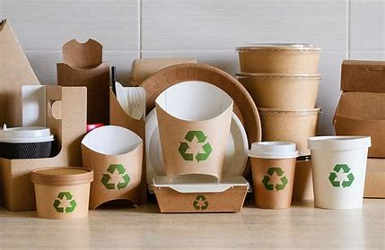

Wilson, M. *Packaging made from biodegradable materials.* (b2bCentral, 2023)

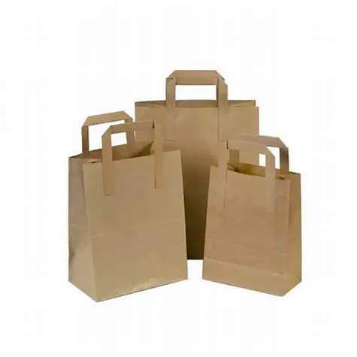

*Paper grocery bag.* (dnpackaging, 2017)

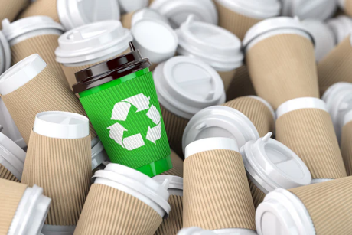

*Recyclable Paper Cups.*(Sustainable Planet, 2021)

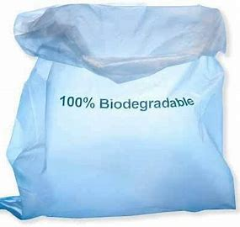

Timsa. *Biodegradable plastic bag on blue. (Freeimages, 2024)*

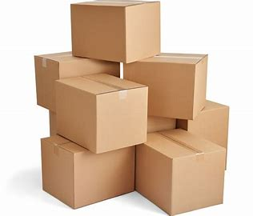

*Biodegradable boxes.* (Planetpapernews, 2018)

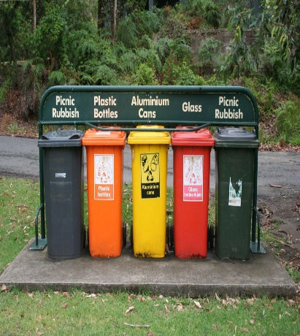

Blanda, E. *Separate containers for various recyclable items are provided to encourage people to recycle*. (Saving Earth, 2022)

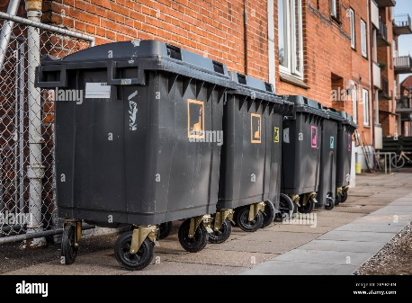

Nymann, K. *Garbage cans for waste sorting*. (imageBROKER, 2015)

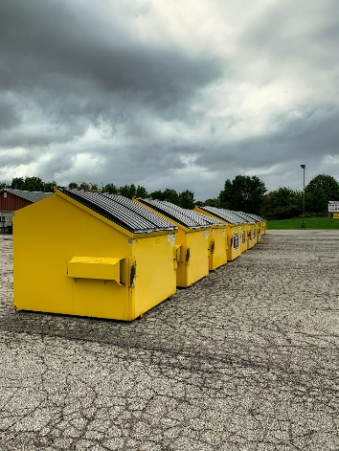

Saunders, L. *Big, Yellow Garbage Bins*. (Pixels, 2024)

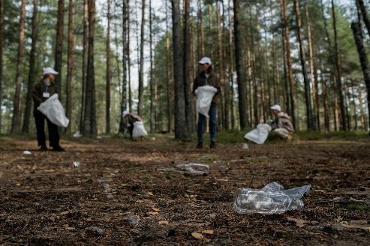

Lach, R. *A Cleanup Community Picking Up Recyclables*. (Pixels, 2021)

Moody, R. 2024.The importance of website navigation. *Stryve*. Available at: <https://www.stryvemarketing.com/blog/website-navigation/> . [Accessed at, 01 April 2025]